**STEPS TO PERFOM STOCK MARKET REAL-TIME ANALYSIS USING KAFKA**

Creating an AWS EC2 instance with the name "kafka-stock-market-project" involves several steps. Before you begin, make sure you have an AWS account and necessary permissions. Here's a step-by-step guide:

1. **Sign in to AWS Console:** Open a web browser and navigate to the AWS Management Console (<https://aws.amazon.com/>). Sign in with your AWS account credentials.
2. **Choose the Region:** In the AWS Management Console, select the AWS region where you want to create your EC2 instance. Ensure that the services you plan to use are available in that region.
3. **Navigate to EC2 Dashboard:** Click on "Services" in the top-left corner and select "EC2" under the "Compute" section. This will take you to the EC2 Dashboard.
4. **Launch an Instance:** To launch an EC2 instance, click the "Instances" link in the left sidebar and then click the "Launch Instances" button.
5. **Choose an Amazon Machine Image (AMI): [ I kept them default i.e. ‘**Amazon Linux (Inferred)**’]**

Select an appropriate AMI that suits your requirements. You can search for an AMI with Kafka pre-installed or use a standard Linux AMI and install Kafka manually.

1. **Choose an Instance Type: [ I kept them default i.e. ‘**t2.micro’**]**

Select an instance type based on your performance and resource requirements. For a basic setup, you can start with a t2.micro or t3.micro instance.

1. **Keep all network settings to default.**
2. **Review Instance Launch:**

Review your instance configuration to ensure it's accurate.

1. **Launch the Instance:**

Click the "Launch" button to create your instance.

1. **Create or Use an Existing Key Pair:**

You will need to either create a new key pair named “kafka-stock-market-project.pem”. Download the private key (.pem) file and keep it secure.

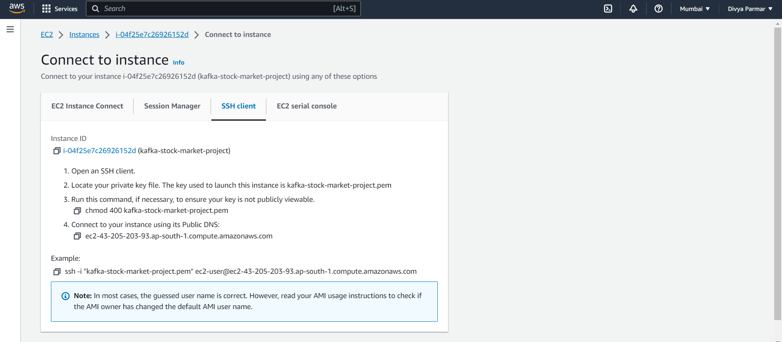

1. **Launch Status:**

After launching, you'll see a confirmation screen. Make note of the instance's public IP address.

1. **Access the Instance:**

Use an SSH client to connect to your instance using the private key you downloaded earlier. The command will look like this in the image above:

ssh -i /path/to/your-key.pem ec2-user@<your-instance-public-ip>

__________________________________________________________________________________

**For installing kafka in EC2:**

Open cmd:

1. Navigate to the folder where private key is present then run this command

ssh -i "kafka-stock-market-project.pem" [ec2-user@ec2-43-205-203-93.ap-south-1.compute.amazonaws.com](mailto:ec2-user@ec2-43-205-203-93.ap-south-1.compute.amazonaws.com)

1. Command for downloading:

wget <https://downloads.apache.org/kafka/3.3.1/kafka_2.12-3.3.1.tgz>

1. command for extracting:

tar -xvf kafka_2.12-3.3.1.tgz

**For installing java-sdk in EC2:**

1. Continue in same terminal.
2. Command for downloading:

sudo yum install java-1.8.0-openjdk

1. command for version check:

java -version

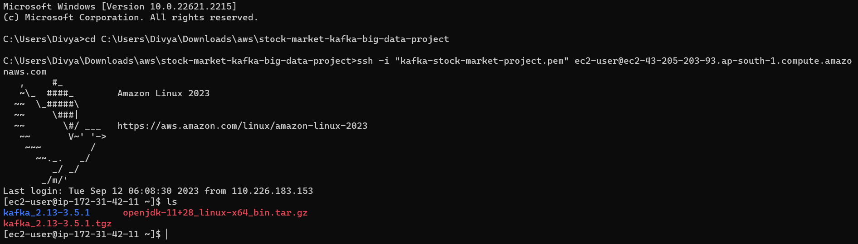

The EC2 file will have these files.

**To Start Zoo-keeper:**

1. continue with same terminal.
2. Go into kafka_2.23-3.5.1

cd kafka_2.23-3.5.1

1. To start zookeeper:

bin/zookeeper-server-start.sh config/zookeeper.properties

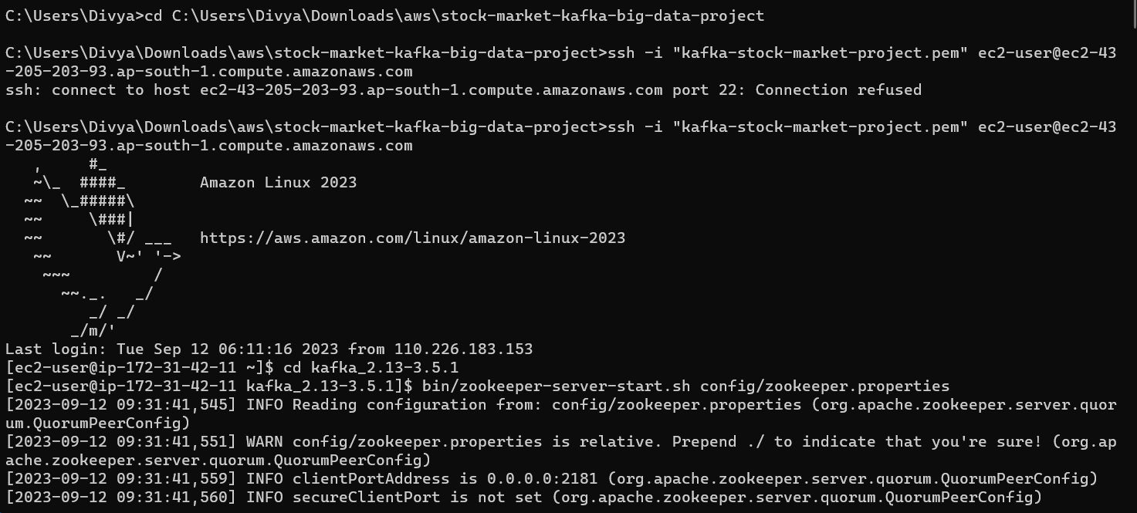

**Start Kafka-server:**

1. Duplicate the session & enter in a new console
2. To increase the memory for kafka server.

export KAFKA_HEAP_OPTS="-Xmx256M -Xms128M"

cd kafka_2.12-3.3.1

1. To start kafka server:

bin/kafka-server-start.sh config/server.properties

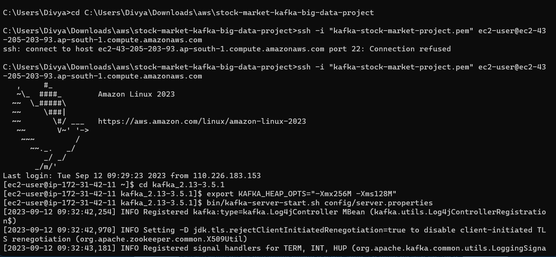

1. It is pointing to private server , change server.properties so that it can run in public IP
2. To do this , you can follow any of the 2 approaches shared below--

Do a "sudo nano config/server.properties" - change ADVERTISED_LISTENERS to public ip of the EC2 instance



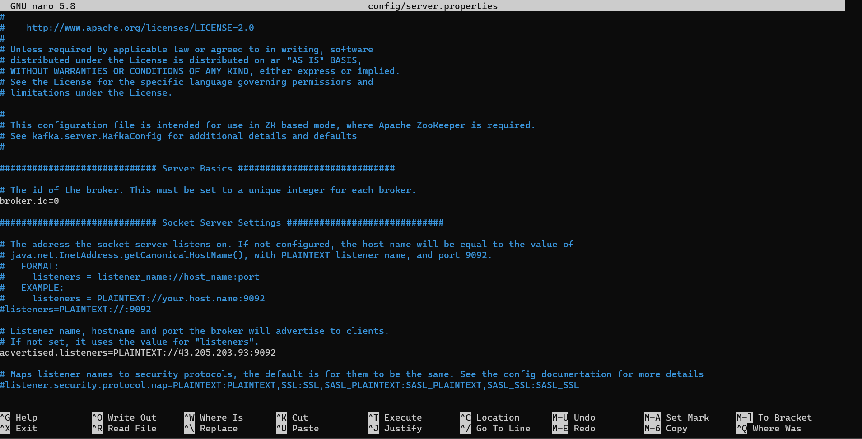

**Create the topic:**

-----------------------------

1. Duplicate the session & enter in a new console –
2. Start kafka server

cd kafka_2.12-3.3.1

bin/kafka-topics.sh --create --topic demo_testing2 --bootstrap-server 43.205.203.93:9092 --replication-factor 1 --partitions 1

**Start Producer:**

--------------------------

bin/kafka-console-producer.sh --topic demo_testing2 --bootstrap-server 43.205.203.93:9092

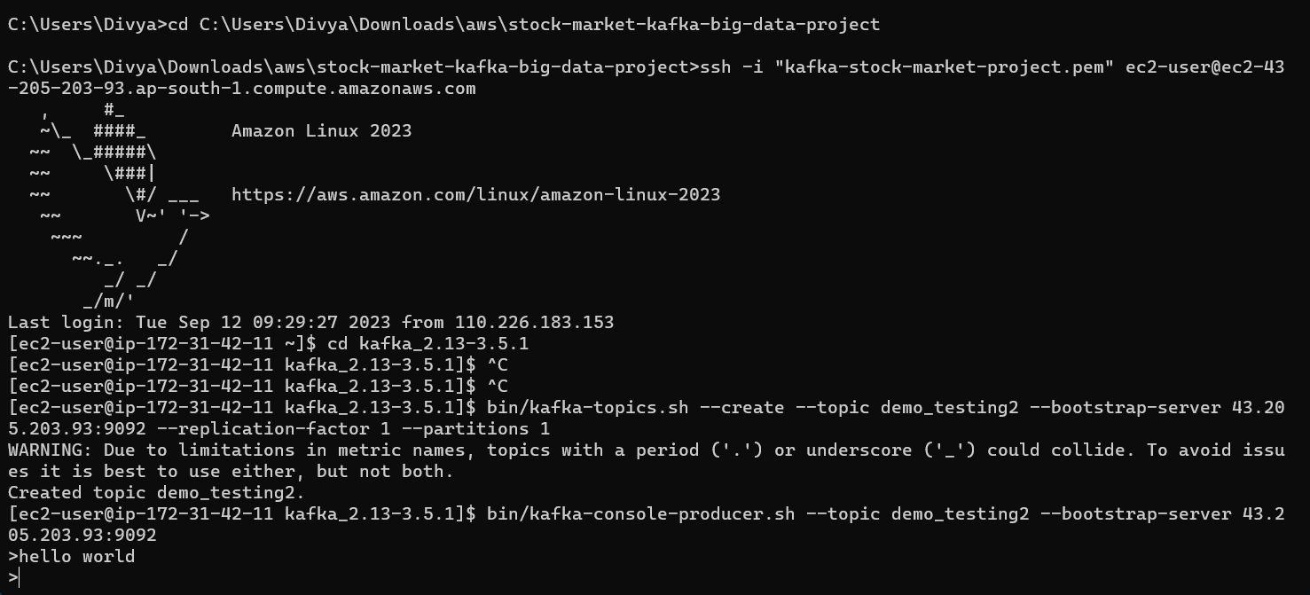

**Start Consumer:**

-------------------------

Duplicate the session & enter in a new console --

cd kafka_2.12-3.3.1

bin/kafka-console-consumer.sh --topic demo_testing2 --bootstrap-server 43.205.203.93:9092

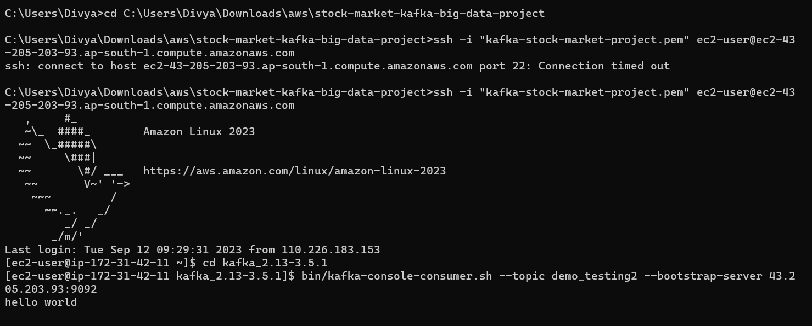

In another window run this command if aws CLI is preinstalled else install it

Give the details of the IAM programmatic users key

